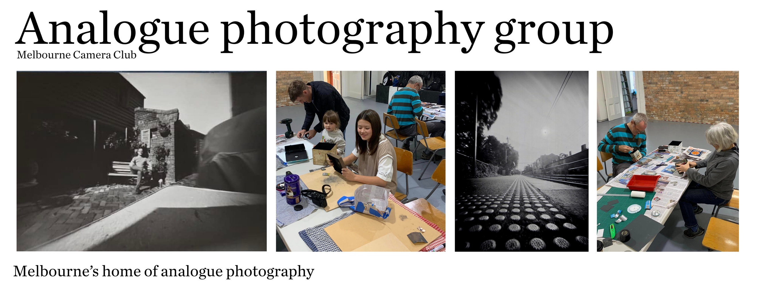

4 X 5 Large Format Film Cameras – Workshop notes.

Welcome to the world of ‘Large Format Photography ‘.
You are about to learn the process of creating a photograph that is as enjoyable as hanging a framed image on the wall.

Today we will discuss the various types of L/F cameras , Lenses and other equipment used in large format photography.

There are basically three types of cameras:
(i) The Monorail ,
(ii) The Metal Folder,
(iii) The Wooden Folder.

All of the above are used with the camera mounted on a tripod. The image being taken is viewed and focussed on the rear ground glass whilst the photographer has his or her head under a dark cloth.

There will be one of each type of camera set up on display today. Camera movements usually feature on 4 X 5 cameras, and you will be shown how they are applied on these cameras at the workshop.

Lenses for large format cameras usually have a built in shutter and this is then mounted on to a ‘Lens board ‘ this is usually made to a size to fit each camera .

Lens focal length for 4x5 is approx. 3X that of 35mm cameras, but as the two film areas are different there are some differences.
50mm on a 35mm camera = 135mm , 150mm or perhaps 180mm on a 4 X 5 camera.

Also, large format lenses are usually selected with excess coverage so that various camera movements can be used without vignetting of the corners of the negatives.
Large format cameras are not always the best cameras for all pictures.

Some of the positive features of the 4 X 5 view camera:
(i) Large film area permits greater enlargements
(ii) Finer grain possible in all images.
(iii) Zone System Development possible.
(iv) Greater depth of field possible when using movements.
(v) Slower picture taking.
(vi) More ‘Keepers‘ means less film is used.

Some of the negatives when using the 4X5 view camera:
(i) Not really suitable for ‘Moving subjects‘
(ii) Difficult to operate in both wet and windy conditions.
(iii) Can be bulky or heavy to operate away from the car.
(iv) Almost all of these cameras are only available second hand.
(v) Some of the early lenses are unable to be repaired.

4 X 5 sheet film is available in Color negative, Color slide, and Black and white.

Film processing is still possible in commercial labs and there are plenty of choices for chemistry if you wish to ‘DIY ‘.

The MCC darkroom has a 4 X 5 enlarger and other processing options.

Equipment needed for 4 X 5 Film photography :-
(i) A suitable TRIPOD – mut be firm enough to carry the weight of the camera,
(ii) Some form of tripod head , either a ‘Ball head‘ or ‘three way head‘
(iii) A light meter, or phone app, or sunny 16 rule.
(iv) A note book to record details so correct development can be applied.
(v) Perhaps three loaded double dark film holders, 6 sheets.
(vi) A suitable ‘dark cloth‘ to view and focus in bright conditions.
(vii) A viewing loupe 3 X, up to 5 X ( 50mm camera lens works well )
(viii) A suitable ‘Cable release‘ to make the exposures.

Not necessary but of help :-
An exposure compensation method when extending the bellows for close -ups.

The Quick Disc :- http://www.salzgeber.at/disc/ download for free, print it out no need for special calculations, an example will be passed around .

A DIY Viewing Frame, this allows you to try out a composition before setting up the camera and tripod, an example of a D I Y one will be passed around.

You tube videos :- there are many available , try this one , it is an excellent demo of camera movements . The View Camera Store – Fred Newman owner.
A 9 minute video https://www.youtube.com/watch?v=0JU-eHpk97Y

Also a good one on movements for focus.
https://www.youtube.com/watch?v=0JU-eHpk97Y

Creative Challenges and Simple Solutions
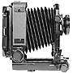 | Controlling Perspective and Parallel Lines  Challenge: You want to photograph a building, or a stand of trees, yet keep all lines parallel even though you must angle the camera upwards to encompass the scene.  Solution: Rise. First, align the camera back parallel to the subject. Then, by using the rise movement, the lens' point of view is moved above eye level, thereby keeping vertical lines parallel. Rise, fall and shift are all parallel movements that move the lens up, down and sideways relative to the center of the camera back.
Increased Control of Perspective and Parallel Lines
Challenge: You need more control of perspective than you can achieve with front rise, fall and shift.
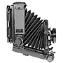 | Solution: Drop Bed - Front and rear are tilted backward at the same degree and thereby kept parallel, giving the effect of increased Front Fall.
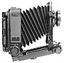 | Incline Bed - Front and rear are tilted forward at the same degree and kept parallel, giving the effect of increased Front Rise.
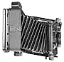 | Shift Bed - Front and rear are swung in the same direction to the same degree, giving the same effect as Shift, but with dramatically increased control.
Increasing Depth of Field
Challenge: You see a vast landscape with a field of flowers and distant mountains. You want to have both the flowers near the camera and the distant mountain in focus at the same time. Even if you used the smallest aperture on your lens, you might still need greater depth-of-field.
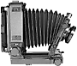 | Solution: Front Tilt. Tilting the lens forward will extend the plane of focus far beyond the effect of using a small lens aperture and allow you to get near and far objects in focus at the same time. Front tilt is usually combined with using a small aperture such as f/16 or f/22. It does not replace using a small aperture, but rather enhances the effect over a greater subject plane.
 | Challenge: Imagine focusing on a white picket fence, running from near to far, diagonally through your composition. With ordinary cameras you can either focus on the beginning, middle, or end of the fence, use a small aperture, and hope to get most of it in focus.
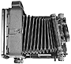 | Solution: Front Swing. With a field camera, you can swing your lens to position it roughly parallel to the fence. This will allow you to get the fence in sharp focus from beginning to end, even with a wide open aperture.
Selective Focus
Challenge: You want to focus on just one leaf or flower and leave everything else in the scene a soft blur. Or, you want to recreate an effect you may have seen in a fashion magazine where only the model's eyes are sharp, and all the clothes are softly blurred.
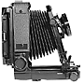 | Solution: Front Tilt-Backward can be used to accomplish these selective focus effects with ease. Front swing can be used for a similar effect with objects to the left or right of your composition center. Swinging in either direction will bring objects in or out of focus.
Correct or Distort the Shape or Size of An Object
Challenge: You want to emphasize a large rock, or other visual element in the foreground of a landscape.
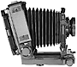 | Solution: Rear Tilt. By tilting the back away from the lens, you will notice that the size and shape of objects in the foreground become exaggerated. Similarly,
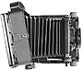 | Rear Swing will pivot the back from side to side, manipulating the shape of objects to the right or left of the composition.

